Brings you one more opportunity for reliving the
IRAN

TRAVEL WITH THE EXPERT IN ORDER TO EXPERIENCE THE RELIGION:

KHOJESTE MISTREE

WILL BE YOUR GUIDE AND FRIEND THROUGHOUT THE TOUR

14 days - Best Value For Money
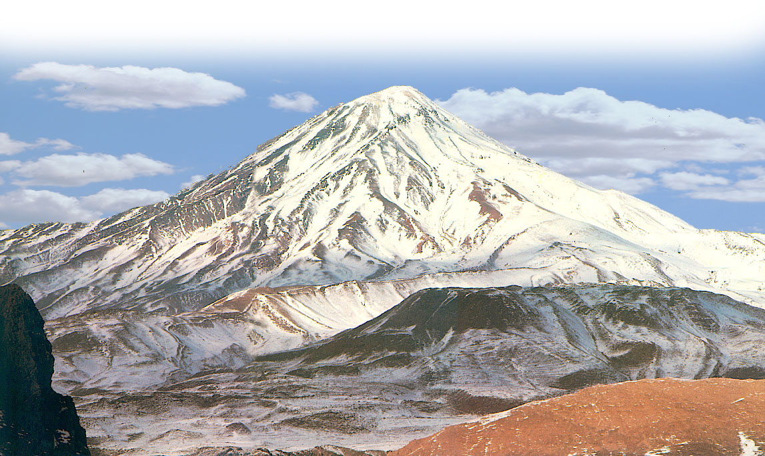
Departure: 14th, Apr. 2006

Return : 28th, Apr. 2006

Visiting:
TEHRAN  KERMANSHAH  TAQ –e BUSTAN 
ISFAHAN  THE OLDEST BRIDGE IN THE WORLD 
 KUH-e ALVAND  ALI SADR CAVES  
SHIRAZ  PERSEPOLIS/TAKHT –e JAMSHEED  
 NAQSH –e RUSTOM  PASARGADAE  
YAZD & ITS ENVIRONS (INCLUDING THE PIRS AND SOME IMPORTANT FIRE TEMPLES) 
         JASHANS AT MT.DEMAVAND & PIR-e SABZ (overnight stay)   

VISIT MORE MUSEUMS, PALACES, SHRINES & HISTORICAL SITES THAN
ANY OTHER INDIA BASED TOUR GROUP!!

Unique educational action packed tour that will rekindle your
religious passion
and give you and exciting holiday.

